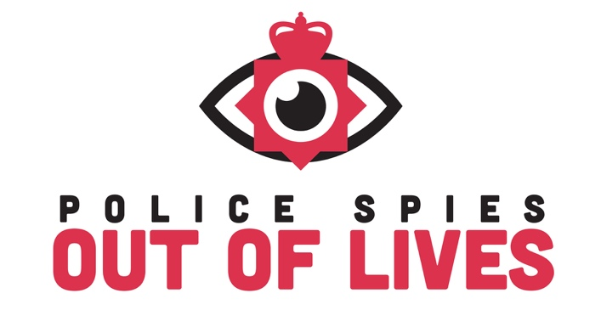
WRITE TO YOUR MP TO REFORM
THE COVERT HUMAN INTELLIGENCE (CRIMINAL CONDUCT) ACT 2021

TEMPLATE

Find your MP here: https://members.parliament.uk/FindYourMP

Please copy the template below and feel free to add in your own personal message.

Dear XXX

I am writing to ask you to join me in supporting the women who have been deceived into intimate sexual relationships with undercover police officers.

The abuse these women suffered resulting from Metropolitan Police deployments should never have been allowed to happen. The Metropolitan Police Service has admitted these relationships should not have happened, but there is still no law to make it a crime for a police officer to have a sexual relationship whilst on duty in an undercover identity. The most recent case of an undercover officer deceiving his way into an intimate relationship widens the issue beyond the Metropolitan Police. Revealed in the Guardian in September 2023, this latest case occurred in the Avon and Somerset Constabulary: ‘Mary’ was deceived into a nineteen-year relationship by an undercover officer who even fathered her child.

Since March 2021, the situation has worsened with the government’s introduction of new legislation: the Covert Human Intelligence Act (CHIS), Criminal Conduct Act - which puts no limits on what undercover police or their informers can be authorised to do. This includes the most heinous crimes of rape and murder.

I’m sure you’re aware of the findings of Baroness Casey’s recent review in which she judged the Metropolitan Police to be institutionally sexist and misogynist. The evidence heard so far from the Undercover Policing Inquiry is pointing to a similar judgement.

EITHER Option 1: In light of this, I would be very grateful if I could meet with you to explain why I feel strongly this new legislation requires reform. OR Option 2: In light of this, I would be grateful if you would confirm your support for reform of the CHIS act.

I look forward to hearing from you,

Kind regards

